NAME: S. DHARANI
REG NO: 192472364
COURSE CODE: DSA0401
NUMPY / PANDAS ANALYSIS – QUESTIONS AND ANSWERS
QUESTION 12: MONTHLY TEMPERATURE AND RAINFALL VISUALIZATION
AIM:
To visualize monthly temperature using a line plot and rainfall using a scatter plot.
ALGORITHM:
1. Import Matplotlib.
2. Create month, temperature and rainfall lists.
3. Plot temperature using plt.plot().
4. Plot rainfall using plt.scatter().
5. Add titles and axis labels and display the graphs.
CODE:
import matplotlib.pyplot as plt
months = ["Jan", "Feb", "Mar", "Apr", "May", "Jun",
"Jul", "Aug", "Sep", "Oct", "Nov", "Dec"]
temperature = [22, 24, 28, 32, 35, 34, 32, 31, 30, 28, 25, 23]
rainfall = [20, 15, 25, 40, 60, 100, 150, 140, 120, 90, 45, 25]
plt.plot(months, temperature, marker="o")
plt.title("Monthly Temperature")
plt.xlabel("Month")
plt.ylabel("Temperature (C)")
plt.show()
plt.scatter(months, rainfall)
plt.title("Monthly Rainfall")
plt.xlabel("Month")
plt.ylabel("Rainfall (mm)")
plt.show()
INPUT:
Temperature and rainfall values for 12 months are given in the code.
OUTPUT:
Two graphs are displayed: monthly temperature line plot and monthly rainfall scatter plot.
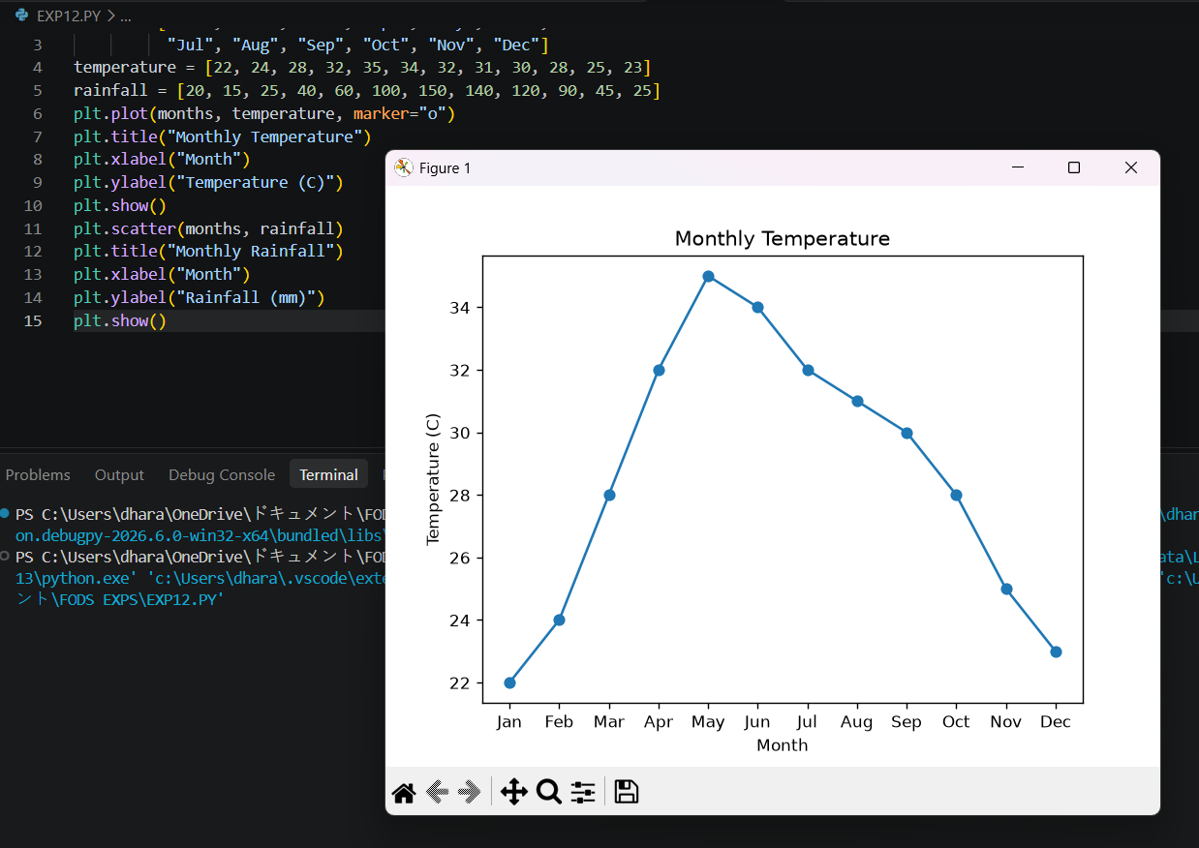
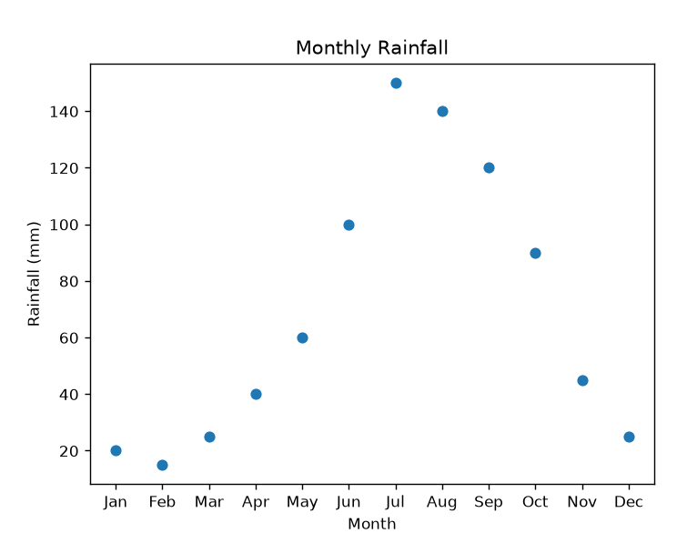
RESULT:
Temperature and rainfall data were visualized successfully.

